A Project Report On

# JOB CONNECT

Post-Graduation

Master of Computer Application Silver Oak College of Computer Application



Submitted to Department of Computer Application

Master of Computer Application Silver Oak College of Computer Application

Silver Oak University

Submitted By:

Siddharth H Rathod (2404070100268)

Jaydip A Poriya

(2404070100284)

Sahil Prajapat

(2404070100325)

Under the Guidance of Mr. AKASH KUMAR

Department of Computer Application Master of Computer Application Silver Oak College of Computer Application



## Silver Oak College of Computer Application Department of Computer Application Masters of Computer Application

**Certificate**

**Date**: /05/2025

This is to certify that the project report submitted along with the project entitled **Job Connect** has been carried out by **Siddharth H Rathod (2404070100268)** under guidance of Mr. Akash Kumar in fulfilment of the MCA (Sem-2), Degree of Master of Computer Application at Silver Oak College of Computer Application, Silver Oak University, Ahmedabad during the academic year 2024-25.

Mr. Akash Kumar

Project Guide HOD



## Silver Oak College of Computer Application Department of Computer Application Masters of Computer Application

**Certificate**

**Date**: /05/2025

This is to certify that the project report submitted along with the project entitled **Job Connect** has been carried out by **Jaydip A Poriya (2404070100284)** under guidance of Mr. Akash Kumar in fulfilment of the MCA (Sem-2), Degree of Master of Computer Application at Silver Oak College of Computer Application, Silver Oak University, Ahmedabad during the academic year 2024-25.

Mr. Akash Kumar

Project Guide HOD



## Silver Oak College of Computer Application Department of Computer Application Masters of Computer Application

**Certificate**

**Date**: /05/2025

This is to certify that the project report submitted along with the project entitled **Job Connect** has been carried out by **Sahil Prajapat (2404070100325)** under guidance of Mr. Akash Kumar in fulfilment of the MCA (Sem-2), Degree of Master of Computer Application at Silver Oak College of Computer Application, Silver Oak University, Ahmedabad during the academic year 2024-25.

Mr. Akash Kumar

Project Guide HOD



# Acknowledgement

I would like to express my heartfelt gratitude to everyone who supported and guided me during the development of my **Job Connect Project**.

Firstly, I am thankful to my college, **Silver Oak University**, for giving me the opportunity to work on this project as part of my academic curriculum. I extend my sincere thanks to my respected faculty members for their continuous support and guidance.

A special thanks to my project guide, **[Guide’s Name]**, for their valuable suggestions, motivation, and timely feedback, which helped me improve the quality of my work.

I also appreciate the help and encouragement from my friends and classmates, who were always ready to assist me when needed.

Finally, I am grateful to my family for their constant support, encouragement, and belief in me throughout this journey.

This project has enhanced my practical skills in PHP, MySQL, and web development and has given me real-world experience in building a functional job portal system.

# 

# Preface

This project report presents the development of a web-based application titled **"Job Connect"**, created as part of my academic curriculum at **Silver Oak University**.

The main purpose of this project is to build a platform that connects job seekers with employers. It allows candidates to register, search for jobs, and apply online, while companies can post job openings and review applications. The project is developed using **PHP** for server-side scripting and **MySQL** for database management.

Through this project, I have gained practical experience in full-stack web development, especially in designing user-friendly interfaces, handling databases, and implementing dynamic features using PHP. This project has also improved my problem-solving, coding, and project management skills.

I hope this project will serve as a useful reference for students and developers who wish to create similar platforms or improve their understanding of web-based systems.

|  |  |  |  |  |  |
| --- | --- | --- | --- | --- | --- |
| **INDEX** | | | | | |
| SR. NO | TITLE | | | | PAGE NUMBER |
| 1 | PROJECT TITLE | | | | 5 |
| 2 | PROBLEM DEFINITION | | | | 5 |
| 3 | NEED OF PROJECT | | | | 6 |
| 3.1 | CURRENT SYSTEM AND ITS DRAWBACK | | | 7 |
| 3.2 | PROPOSED SYSTEM AND ITS FEATURE | | | 7 |
| 4 | REQUIREMENT | | | | 9 |
| 4.1 | SOFTWARE (CLIENT SIDE AND SERVER SIDE) | | | 9 |
| 4.2 | HARDWARE (CLIENT SIDE AND SERVER SIDE) | | | 10 |
| 5 | TIME DURATION | | | | 10 |
| 6 | TECHNOLOGY USED | | | | 10 |
| 7 | FUNCTIONAL AND NON- FUNCTIONAL DEPENDENCY | | | | 11 |
| 8 | DESIGN | | | | 11 |
| 8.1 | | SYSTEM FLOW DIAGRAM | | 11 |
| 8.2 | | UML DIAGRAMS OR DATA FLOW DIAGRAM | | 12 |
| 8.2.1 | USE CASE OR CONTEXT LEVEL / 0 LEVEL | 12 |
| 8.2.2 | ACTIVITY OR FIRST LEVEL | 12 |
| 8.3 | | ER DIAGRAM | | 13 |
| 8.4 | | SCREENSHOTS OF MODULE | | 14 |
| 9 | FUTURE SCOPE | | | | 28 |
| 10 | REFERENCES | | | | 29 |

**1) Project Title:**

### Job Connect

**2) Problem Definition**:

In today’s competitive world, job seekers and employers face difficulties in connecting with each other effectively. Traditional methods of job searching and hiring are often time-consuming, inefficient, and lack proper communication between candidates and companies.

Job Connect aims to solve this problem by providing a web-based platform where:

• Job seekers can easily register, create profiles, search for jobs, and apply online.

• Employers can post job vacancies, view applications, and shortlist suitable candidates.

This system eliminates the need for manual processes and provides a faster, more efficient way to manage recruitment and job search activities. It bridges the gap between job providers and job seekers by bringing them onto a single platform.

**3) Need of Project:**

In the current digital era, the process of job searching and recruitment still faces many challenges. Traditional methods such as newspaper ads, offline applications, and consultancy agencies are time-consuming, less effective, and often limited in reach.

There is a growing need for a centralized online platform that can connect job seekers with potential employers efficiently and quickly.

The Job Connect project is needed to:

Provide a user-friendly and accessible platform for both job seekers and employers.

Make the job search and recruitment process faster and more organized.

Reduce the dependency on third-party services for hiring.

Allow real-time job postings and applications.

Enable easy communication between candidates and recruiters.

**Current Project:**

* The current project titled "Job Connect" is a web-based job portal system developed using PHP, MySQL, HTML, CSS, and JavaScript. It is designed to create an online platform that connects job seekers with employers in an efficient and user-friendly manner.
* The system provides the following main features:
* Job Seeker Module: Allows users to register, log in, create a profile, search for jobs, and apply for suitable job openings.
* Employer Module: Enables companies to register, log in, post job vacancies, and manage applications from job seekers.
* Admin Module: Allows admin to manage users, jobs, and the overall functioning of the platform.
* The goal of the current project is to reduce the communication gap between employers and candidates by offering a centralized platform for job posting and application. It aims to make the hiring process smoother, faster, and more transparent for all users.
* This project is developed as part of my academic curriculum and also serves as practical learning for real-world web development and database management.
* .

**3.1) Drawbacks of the Current Project:**

**Limited Security Features**

The current system lacks advanced security features such as data encryption, secure password handling, and protection against SQL injection or XSS attacks.

**Basic User Interface**

The UI is functional but lacks modern design elements, responsiveness on all devices, and advanced user experience features.

**No Resume Builder or File Analysis**

Job seekers can upload resumes, but there is no resume builder or automated parsing to match skills with job requirements.

**No Email or SMS Notifications**

The system does not send automatic notifications for job application updates or new job postings.

**Limited Search and Filter Options**

Job and candidate search filters are basic and could be improved with advanced options like location, salary range, experience, and job type.

**No Interview Scheduling System**

There is no feature for interview scheduling or video interview integration between employers and job seekers.

**3.2 Features of the Proposed Solution:**

**User Registration and Login**

Separate and secure login systems for job seekers, employers, and admin users.

Manage job seekers and employers

Approve or reject job posts

Monitor system activity

Job Search Job Seeker Dashboard

Create and update profile

Upload resume

Search and apply for jobs

View application history

Employer Dashboard

Post and manage job listings

View applications

Shortlist and contact candidates

Admin Panel

Resume Upload and Management

Job seekers can upload resumes, which employers can download and review.

**Responsive Web Design**

The system is designed to work smoothly on desktops, tablets, and mobile devices.

**Real-time Job Posting and Application**

Jobs can be posted and applied to instantly without delays.

**Simple and User-Friendly Interface**

Easy navigation for users of all levels to access features and information quickly.

**4) Requirement**

**4.1) Software**

* Client side:
* Operating Systems:

Windows 10/11, macOS, iOS, Android

* Web Browsers:

Latest versions of Chrome, Firefox, Safari, Edge

* Development Tools:

HTML, CSS, JavaScript, jQuery

* **Server side:**

PHP , MYSQL

* 1. **Hardware Requirements:**
* Devices:

Desktop/Laptop: Intel i5 or higher, 8GB RAM, 256GB SSD

* Peripherals:

High-resolution monitors for design and development Testing devices for different screen sizes and resolutions.

## 5) Time During:

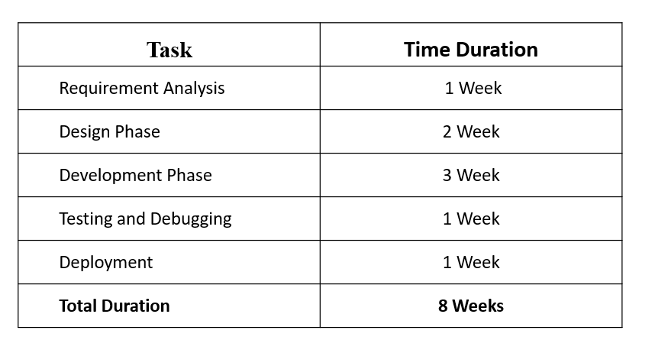

### **6)Technologies Used :**

 **Frontend**: HTML, CSS, jQuery

 **Responsive Design:** Bootstrap

 **Backend:** PHP

**Database:** MySQL



7) **Function and Non Function Dependency :**

* **Functional dependency** User Registration and Login
* Job seekers and employers must be able to register and log in securely.
* Profile Management
* Job seekers can create/edit profiles and upload resumes.
* Employers can manage company details and job postings.
* Job Posting and Management
* Employers can post job openings, edit or delete them as needed.
* **Non-functional dependency**
* The system should load quickly and handle multiple users at once.
* Security
* Passwords must be encrypted.
* User data should be protected from unauthorized access.
* Scalability
* The system should support future growth (more users, features, data).
* Usability
* Interface should be simple, intuitive, and user-friendly.

**8) Design :**

**8.1) System Flow Diagram :**

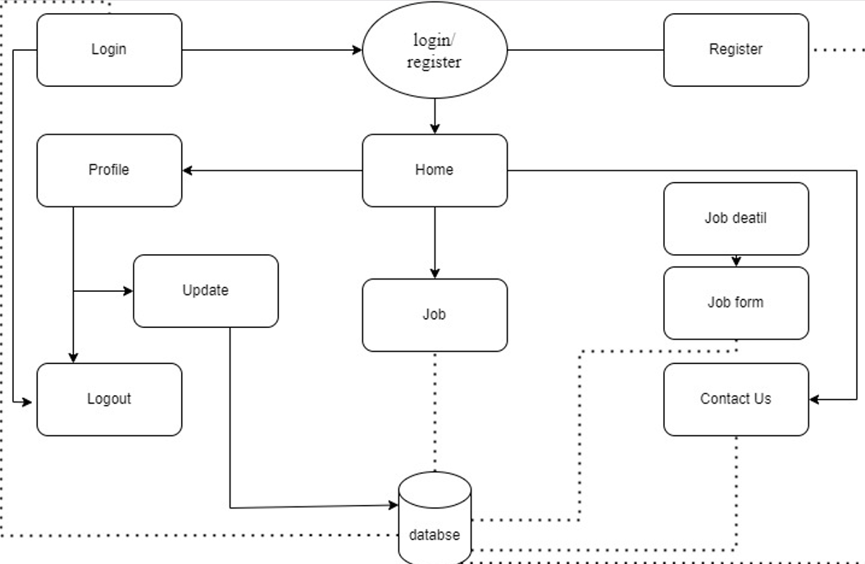 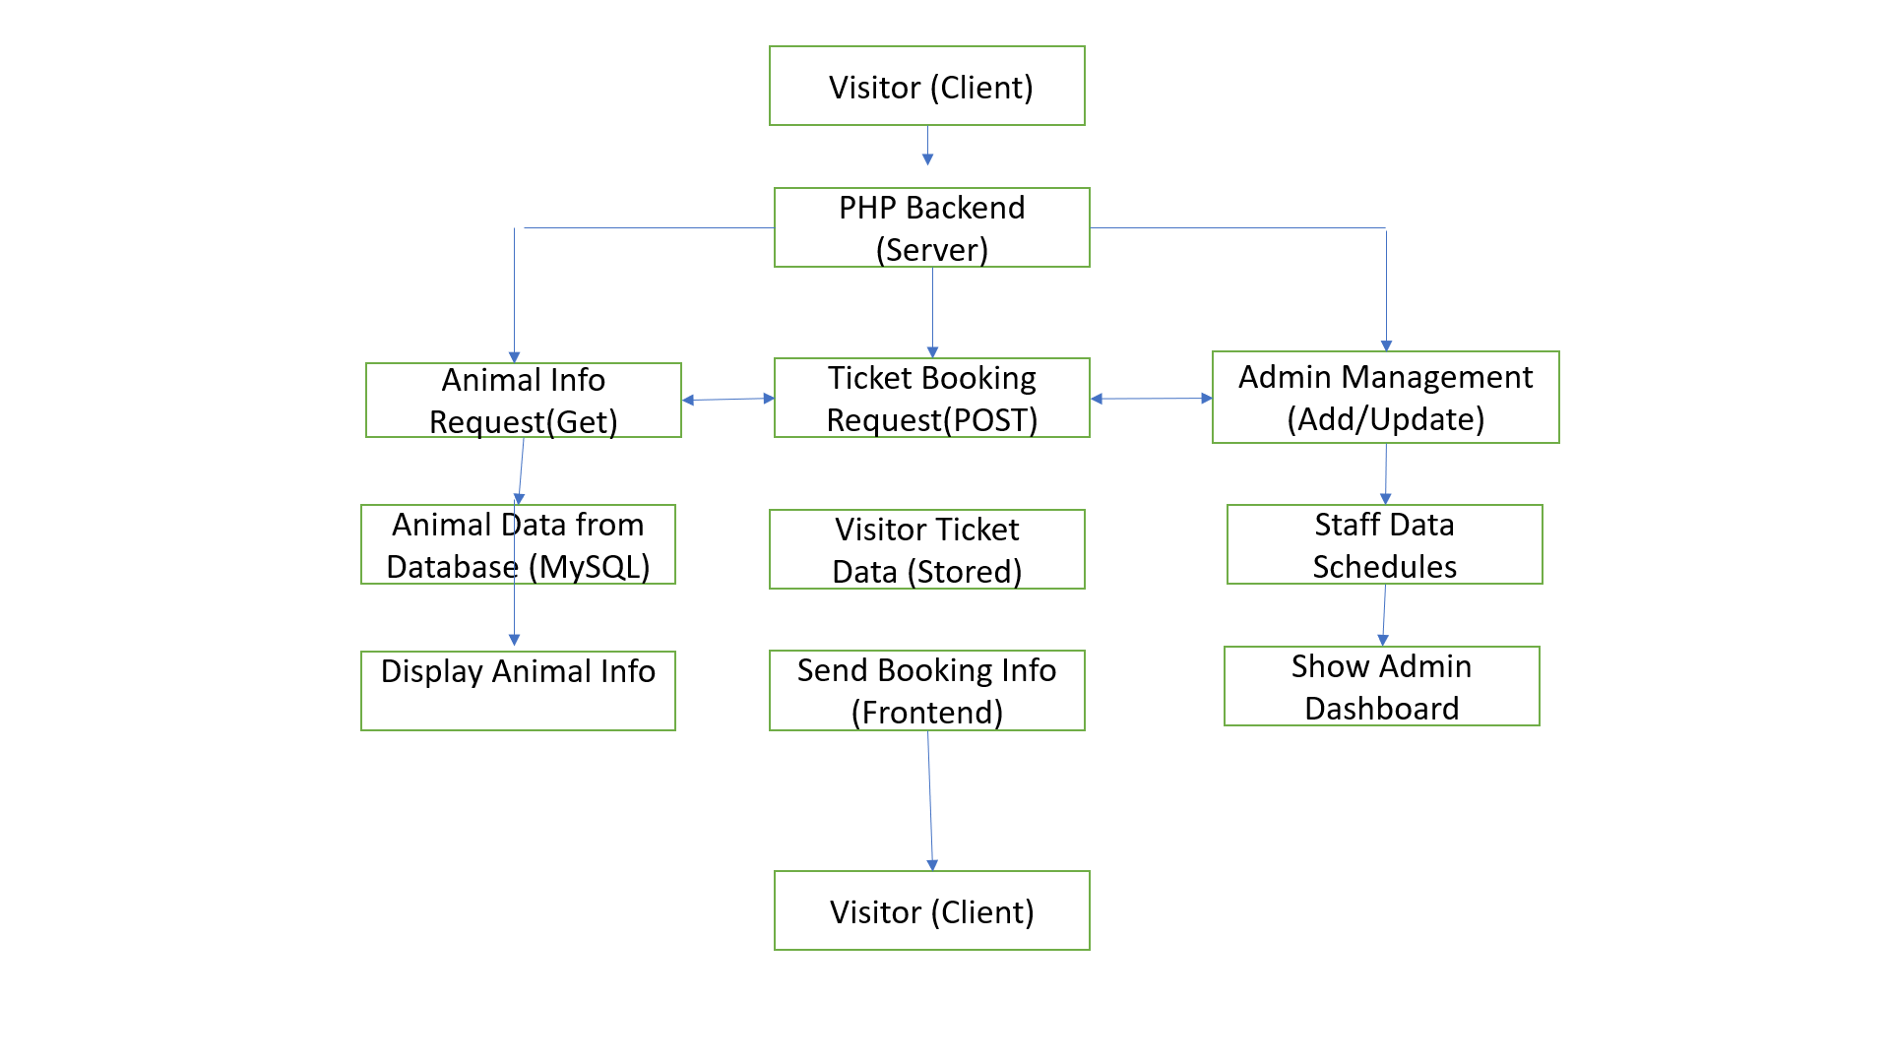

**8.2) Data Flow Diagram :**

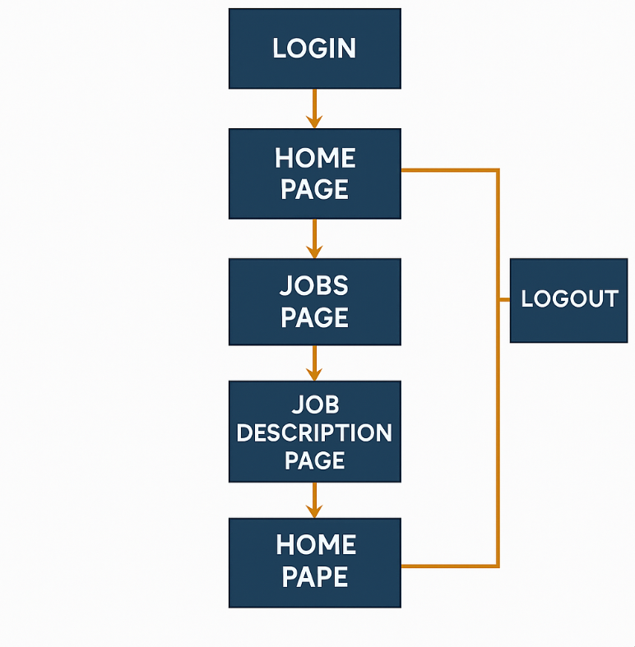

**8.2.2) Activity diagram**

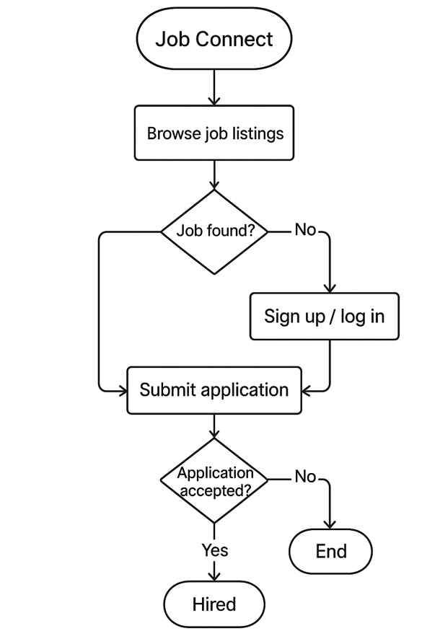 **8.3) E-R Diagram :**

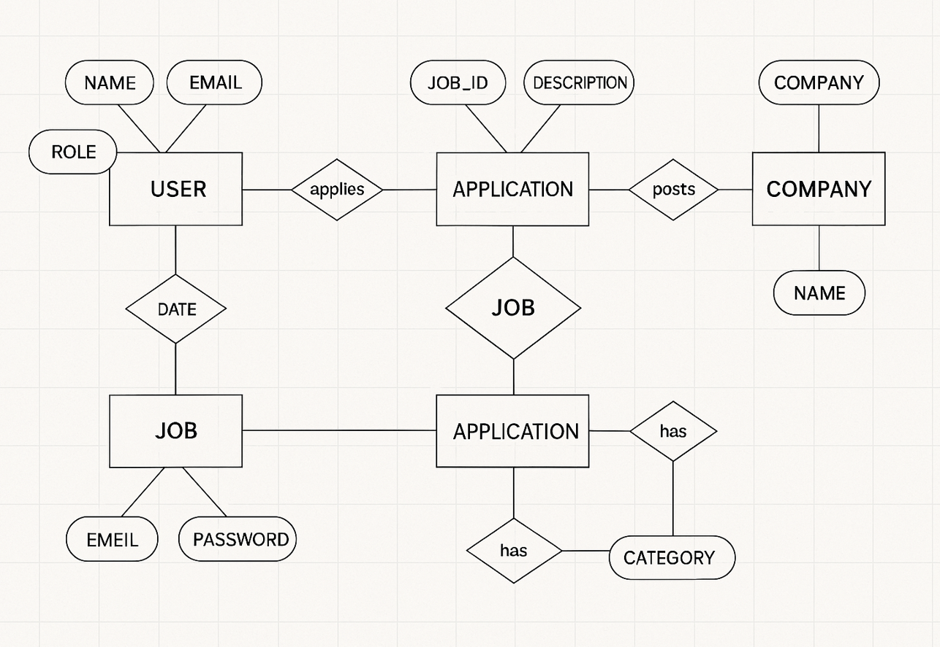

**8.4 Data Dictionary:**

**COMPANY TABLE**

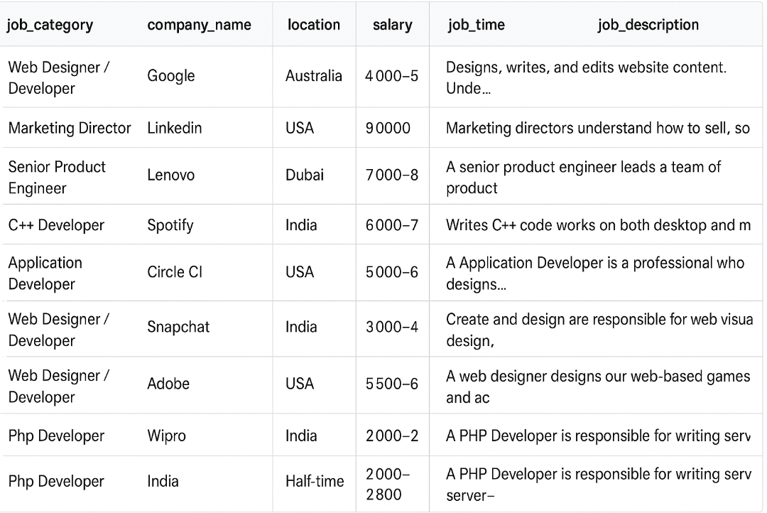

**USER TABLE**

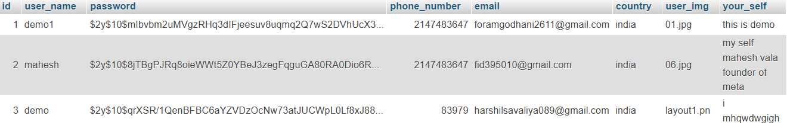

**USER APPLY TABLE**

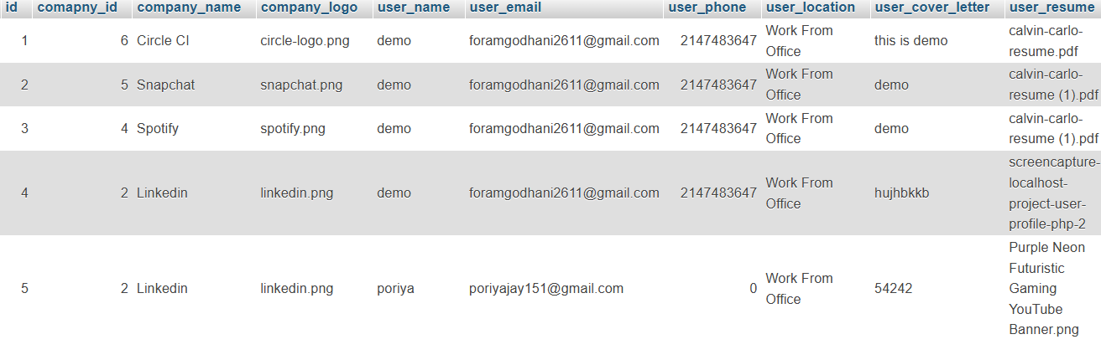

**8.5 Screenshots of Module :**

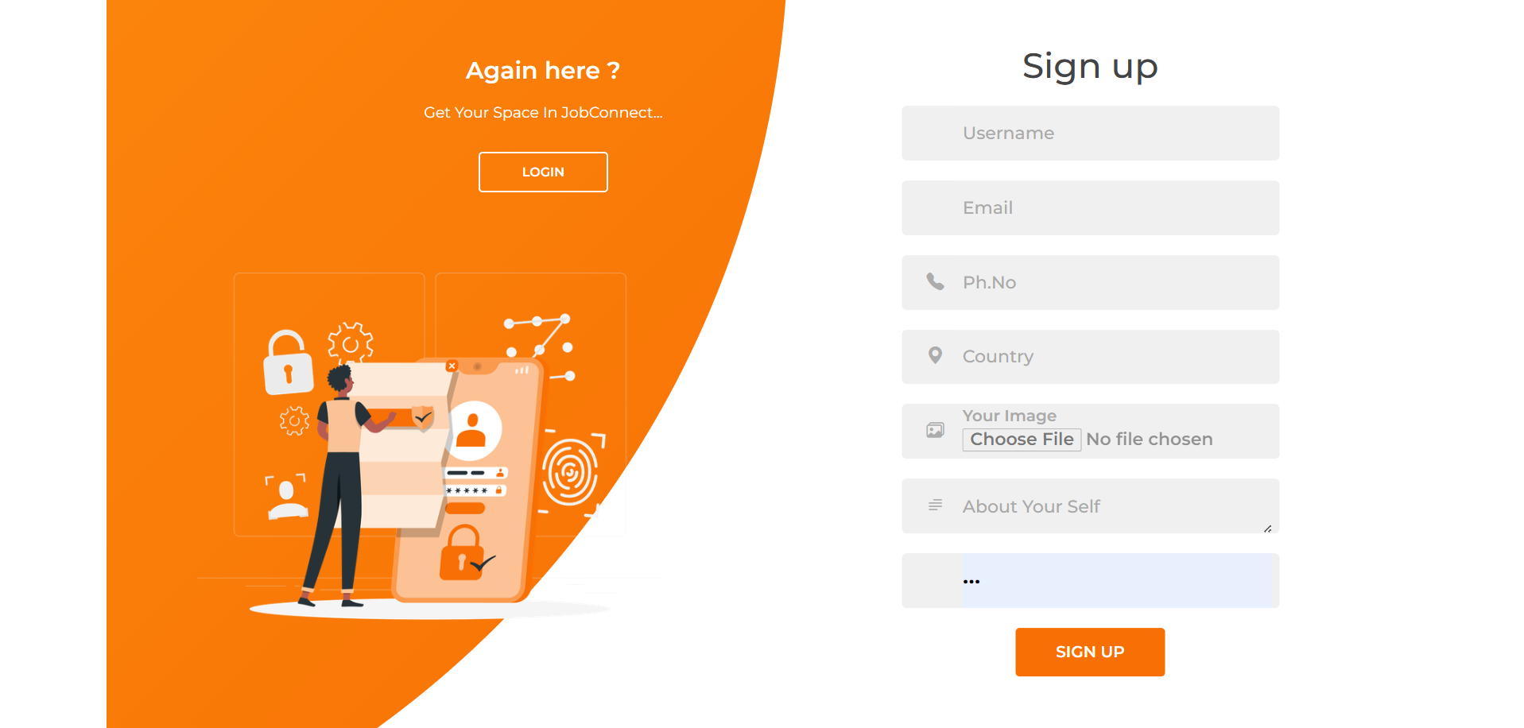

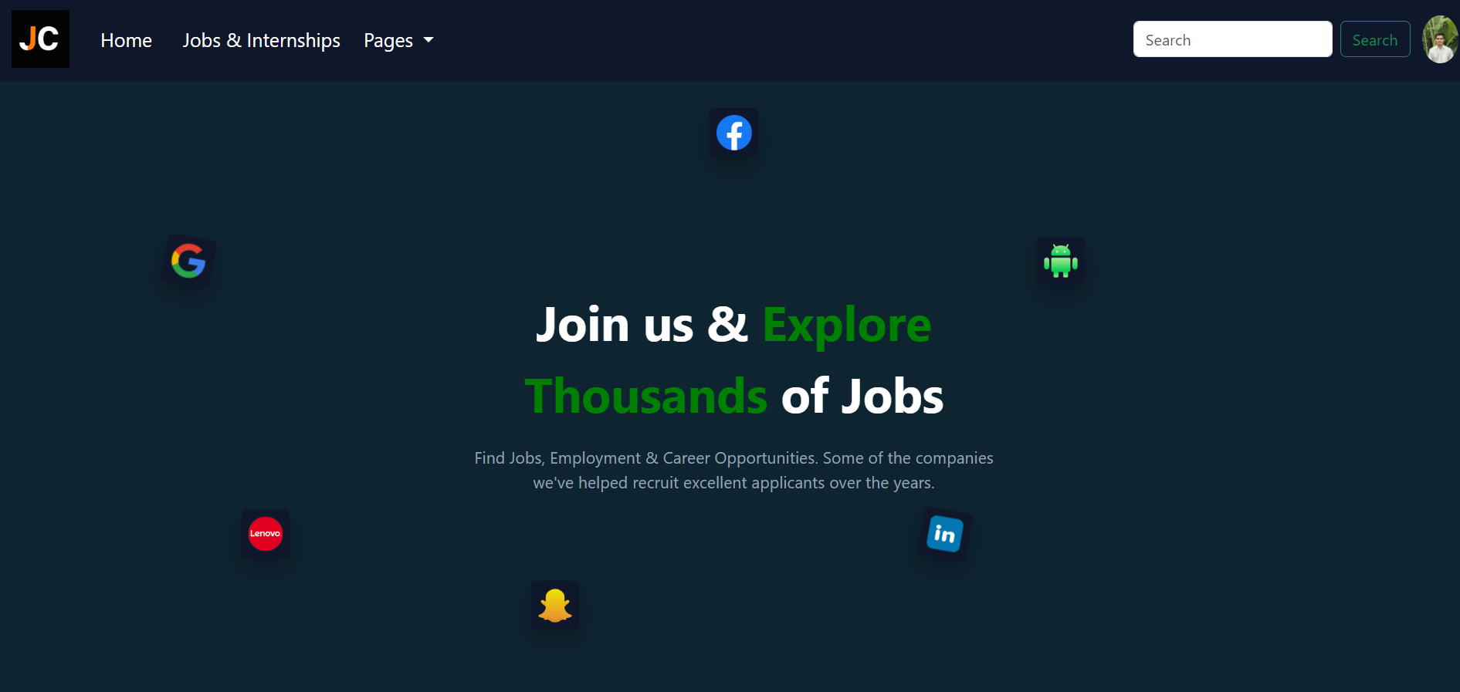



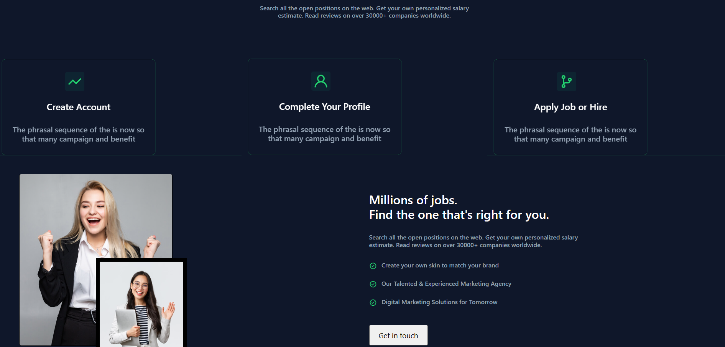

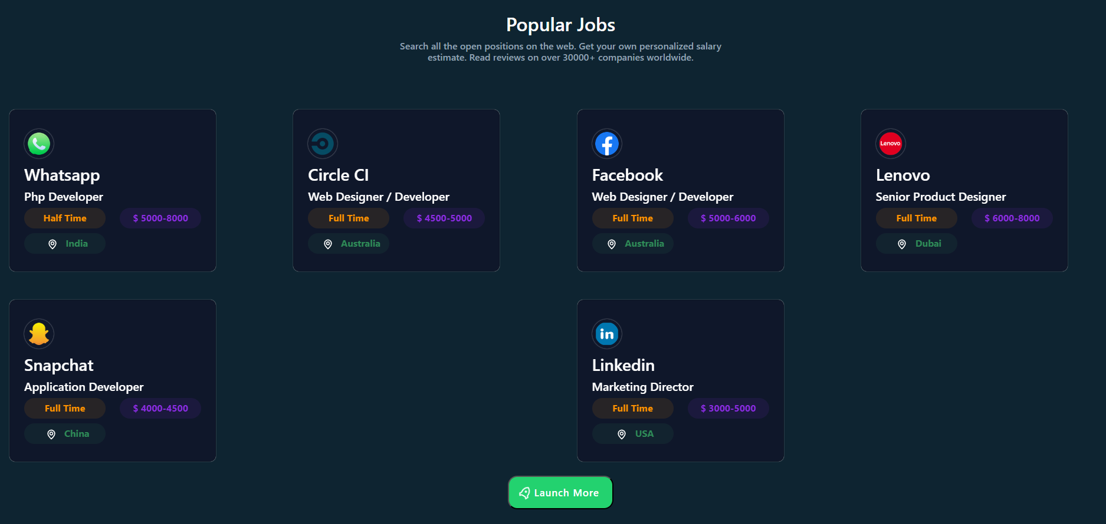

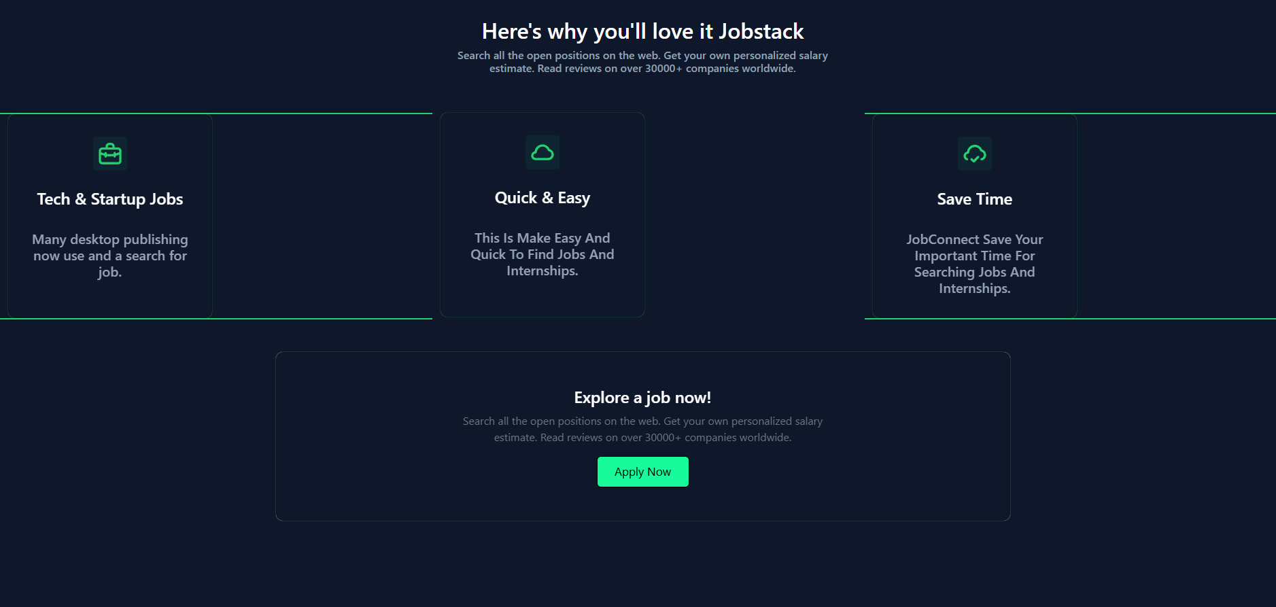



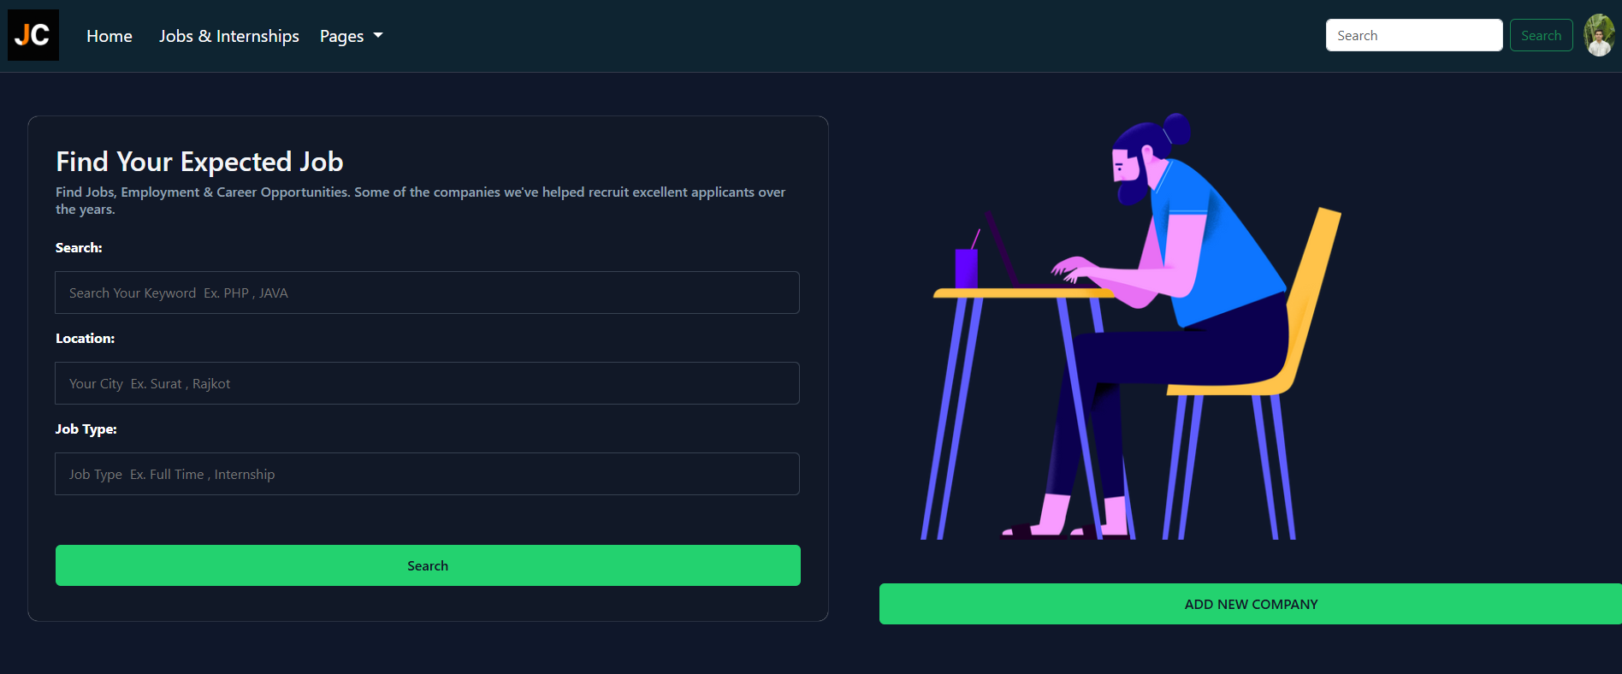

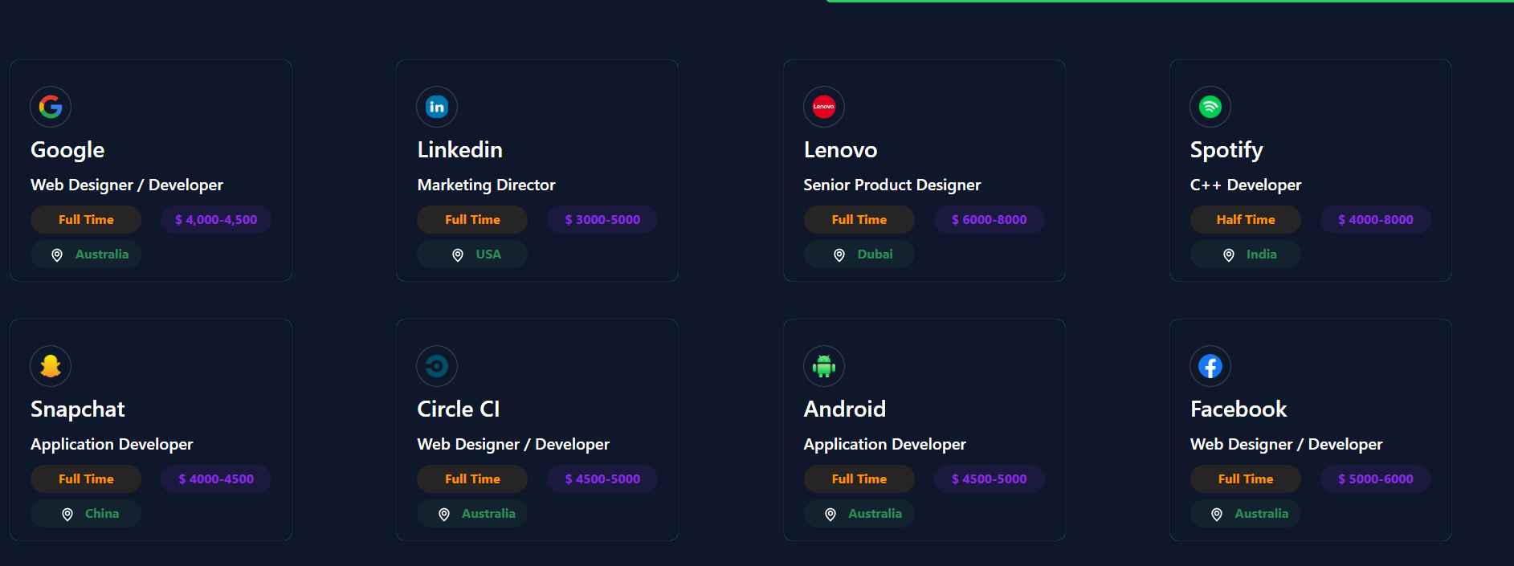

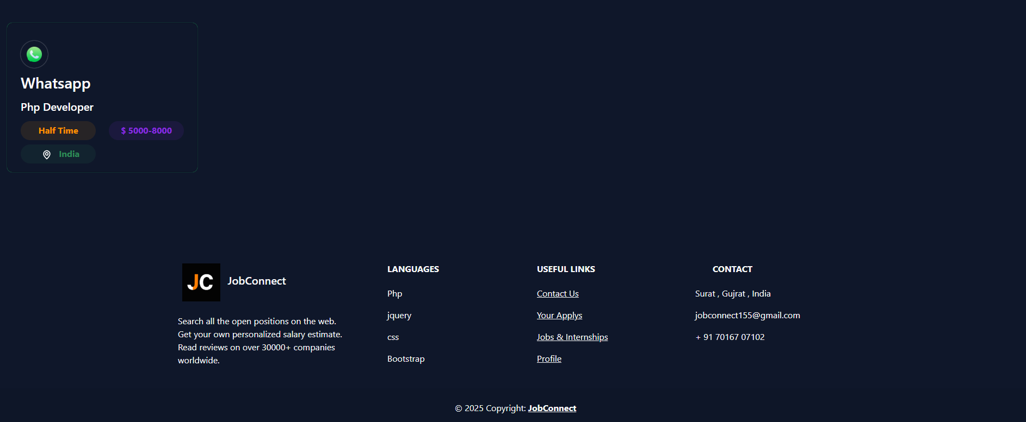

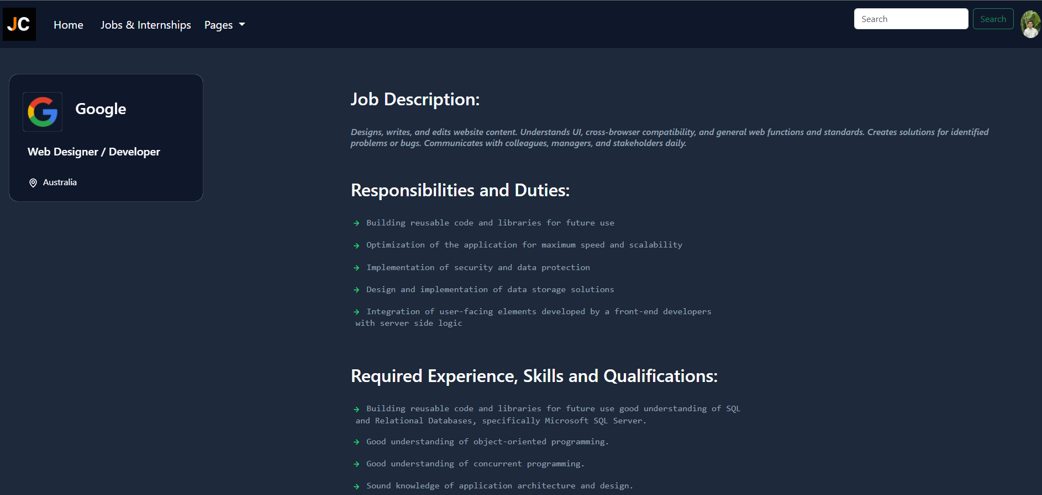

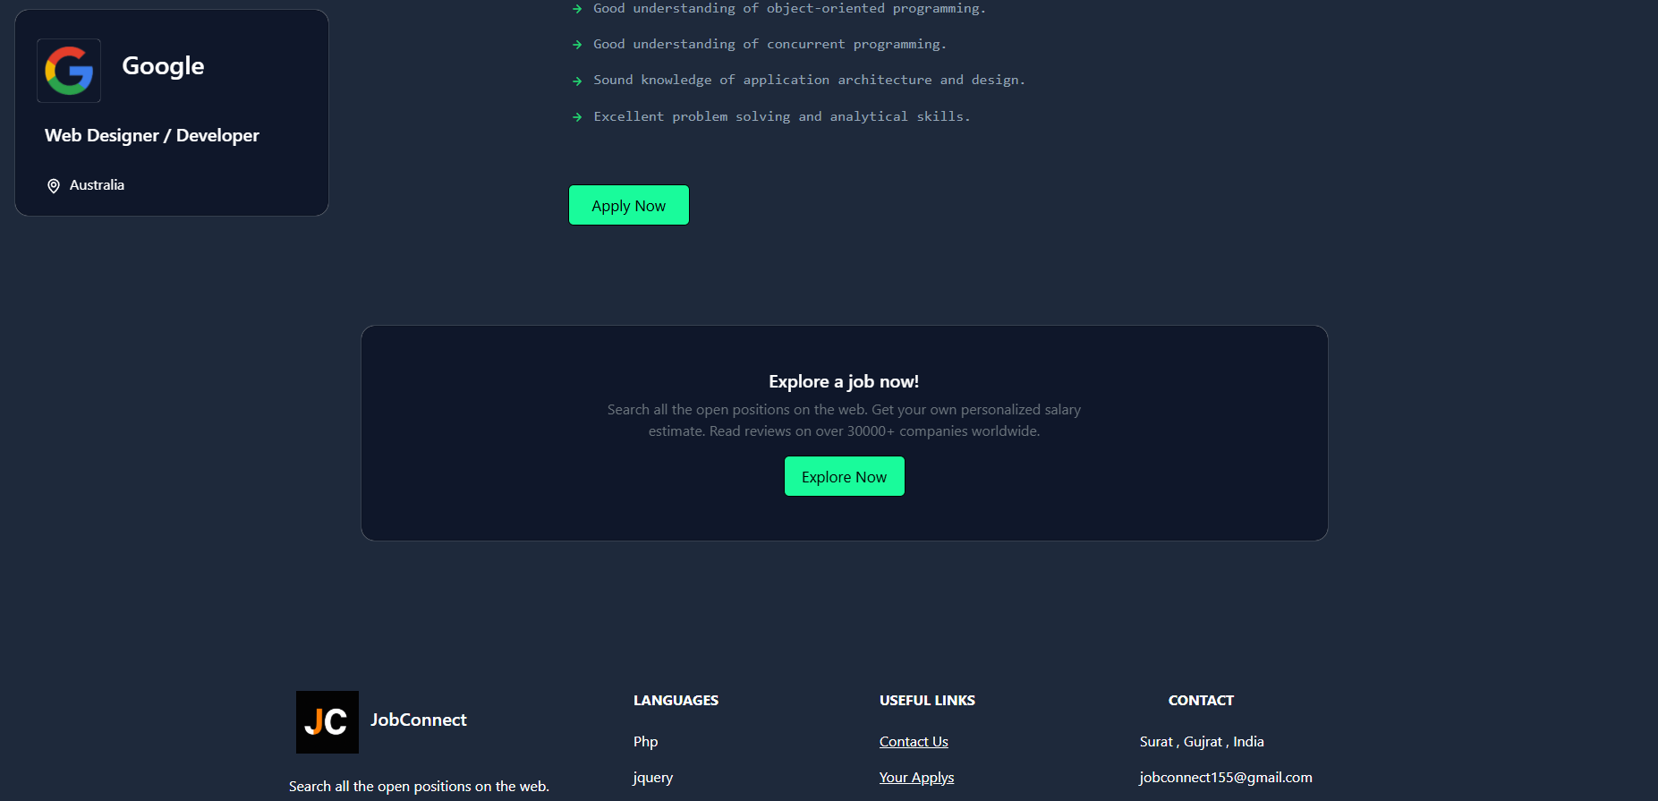

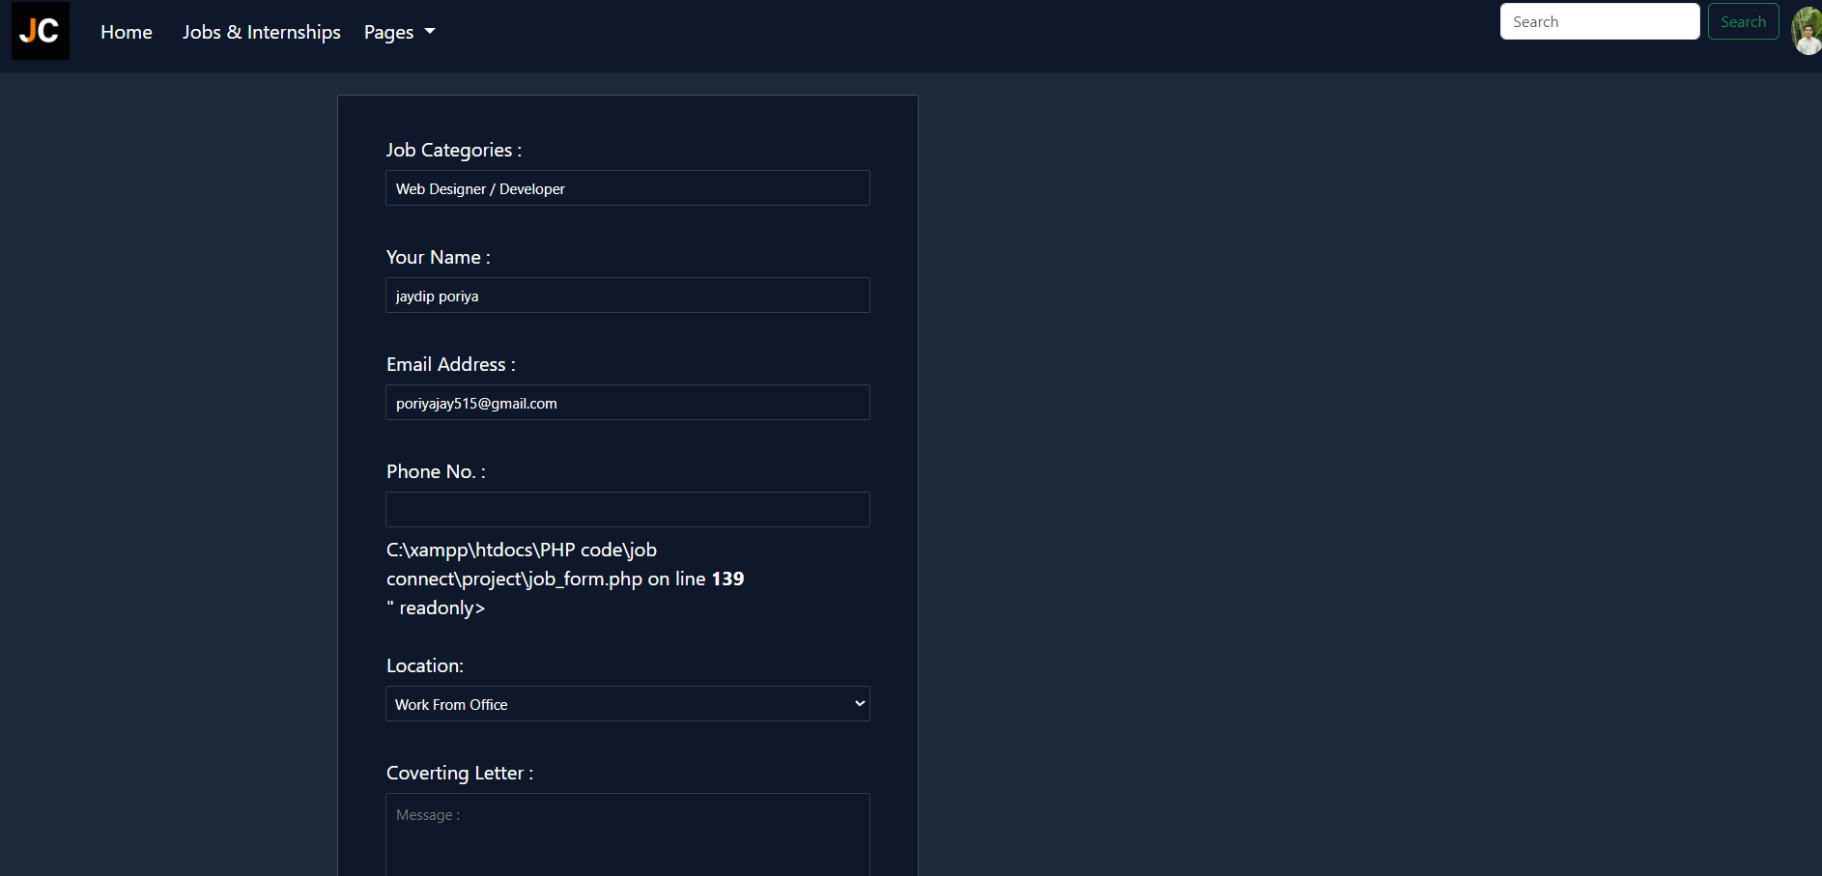

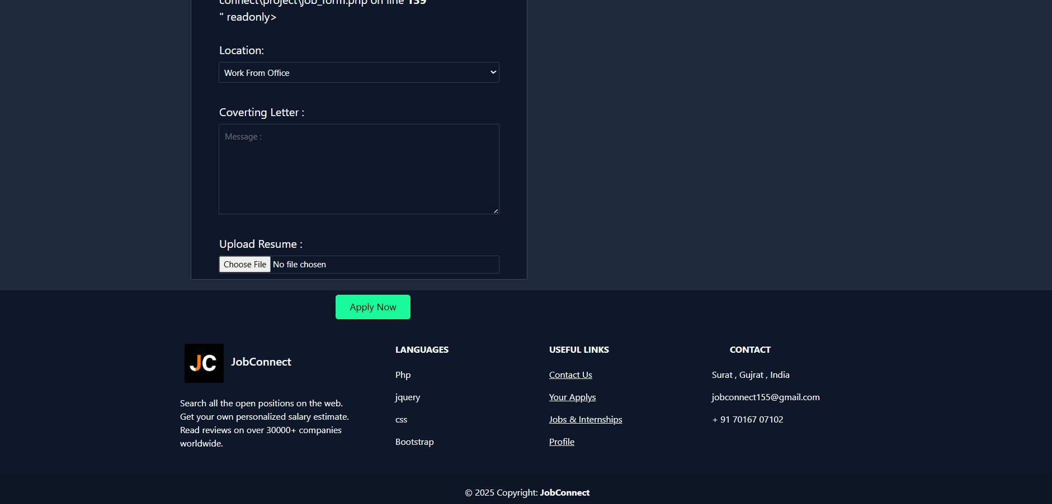

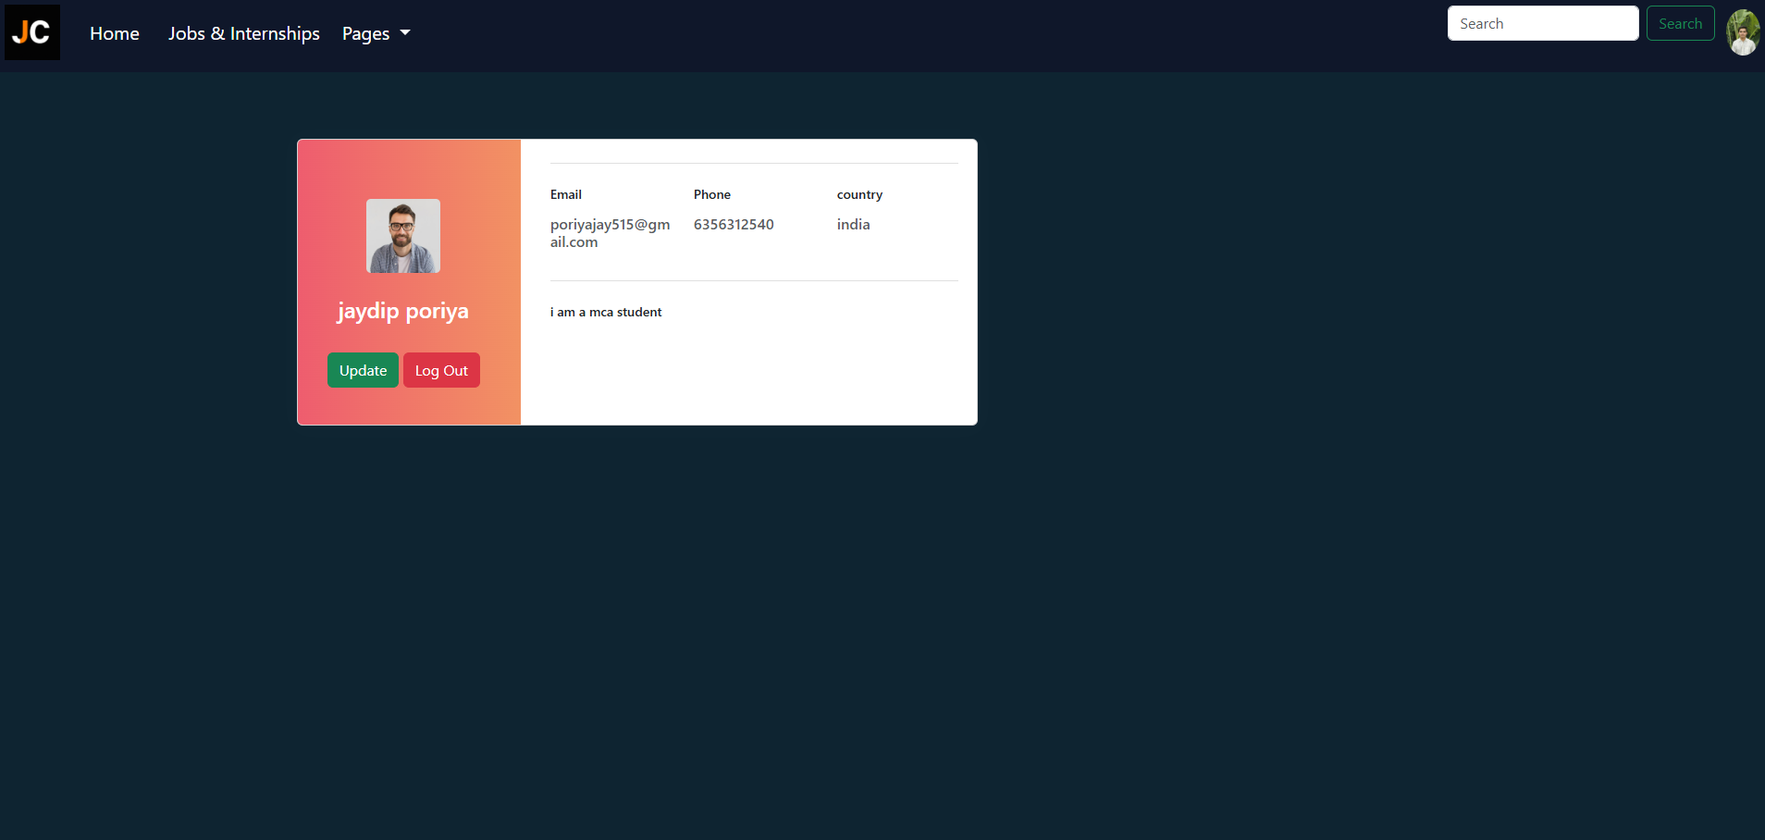

**CONTACT PAGE**

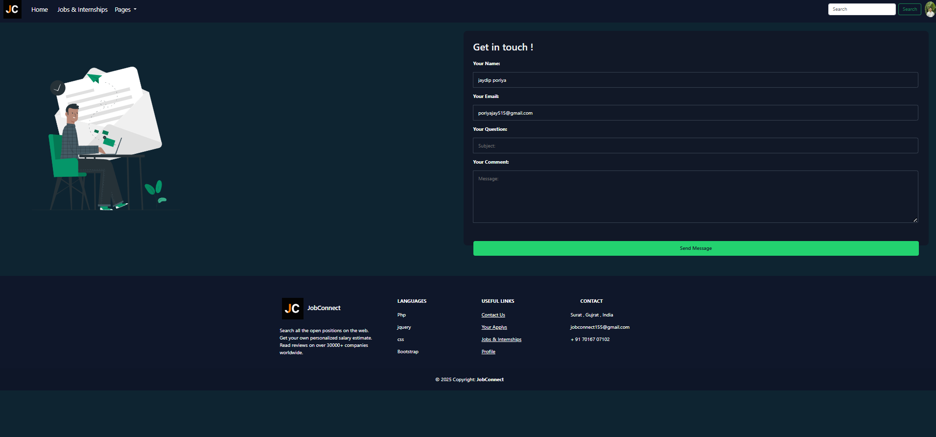

**9) Future Scope :**

**• AI-Powered Job Matching**Integrate machine learning algorithms to analyze user profiles, skills, and preferences to provide intelligent job recommendations and match candidates more accurately to job roles.

**• Resume Builder and Analyzer**Implement a smart resume builder and analyzer that helps users create optimized resumes tailored to job descriptions, increasing their chances of selection.

**• Real-Time Interview Scheduling**Include a feature for seamless interview scheduling with integrated calendar APIs and video conferencing tools like Zoom, Google Meet, or Microsoft Teams.

**• Skill Assessment and Training Modules**Partner with e-learning platforms or build in-house assessments and certification courses that help candidates upskill and become more employable.

**• Analytics Dashboard for Employers**Provide detailed analytics for recruiters, including candidate tracking, engagement metrics, and hiring funnel insights.

**• Freelance and Remote Job Listings**Expand the platform to support freelance gigs, internships**,** and remote job opportunities to cater to a broader user base.

**• Mobile Application**Develop cross-platform mobile apps (iOS/Android) for broader accessibility and user engagement.

**• Multilingual Support**Add support for multiple languages to improve inclusivity and reach users from diverse linguistic backgrounds.

**• Blockchain for Credential Verification**Use blockchain technology to verify academic and professional credentials securely and efficiently.

**• Global Job Opportunities**Collaborate with international companies and recruitment agencies to offer global career opportunities and relocation assistance.

**10) References :**

* **GreeksforGreeks**: https://[www.greekf4greek.com/](http://www.greekf4greek.com/)
* **W3scholl**: https://[www.w3scholl.com/Algebra](http://www.w3scholl.com/Algebra)